hub pricing tool calculation workflow



Document ID | DEV-HUB-SOP-001-v1.0
Product | HUB
Environment | ALL
Confidentiality Level | Internal / Restricted

CONTENTS
1 DOCUMENT INFORMATION 4
1.1 Validation 4
1.2 Document Distribution 4
1.3 Version Control 4
2 PURPOSE & CONTEXT 5
2.1 About this document 5
2.2 Scope 5
2.3 Roles & Responsibilities 6
2.4 Terminology 6
2.5 Conventions Used 6
3 STORAGE CONTAINER PRICING 7
3.1 Vendor Pricing Records 7
3.1.1 Vendor Pricing app in QuickBase 7
3.1.2 Hub app 7
3.2 MySQL Database 8
3.3 Hub App > Pricing Tool 9
3.4 Pricing Adjustments Process 10
3.5 Saving Records in QuickBase 11
3.5.1 Example 13
4 PORTABLE TOILET PRICING 16
4.1 Vendor Pricing Records 16
4.1.1 Vendor Pricing app in QuickBase 16
4.1.2 Hub app 16
4.2 MySQL Database 17
4.3 Hub App > Pricing Tool 18
4.4 Pricing Adjustments Process 19
4.5 Saving Records in QuickBase 20
4.5.1 Example 22
5 ROLL-OFFS PRICING 26
5.1 Vendor Pricing Records 26
5.1.1 Vendor Pricing app in QuickBase 26
5.1.2 Hub app 26
5.2 MySQL Database 27
5.3 Hub App > Pricing Tool 28
5.4 Pricing Adjustments Process 29
5.5 Saving Records in QuickBase 31
5.5.1 Example 33
6 APPROVAL SIGNATURES 36

DOCUMENT INFORMATION

Validation
Name |  | Role | Date (dd/mm/aa)
Issued by | Oscar Rondon | Technical Writer | 19/02/2026
Verified by | Jose Carlos Osuna | Developer | 20/02/2026
Approved by | Anthony Bures | Digital Development Manager | 20/02/2026

Document Distribution
Normal | Role
Jose Carlos Osuna | Developer
Anthony Bures | Digital Development Manager

Version Control
Version | Date | Author | Description of changes
1.0 | 20/02/2026 | Oscar Rondon | First version of the Hub Pricing Calculation Tool

PURPOSE & CONTEXT

About this document
This document describes the technical pricing calculation flow used by the Hub application to generate customer pricing suggestions for:
- Storage Containers
- Portable Toilets
- Roll-Offs
It explains:
- Data synchronization from Vendor Pricing (QuickBase)
- MySQL storage structure
- Pricing adjustment logic
- Suggestion display rules
- Record creation in Sales Management QuickBase
The purpose is to provide engineering, QA, and product teams with a complete understanding of how pricing is calculated and persisted.

Scope
The scope of the pricing tool calculation includes the following.
In scope:
- Vendor Pricing → MySQL sync process
- Pricing Tool filtering logic
- Pricing adjustment algorithm
- Adjustment hierarchy rules
- Field mappings between:
  - Vendor Pricing QuickBase
  - MySQL
  - Hub Pricing Tool
  - Sales Management QuickBase
- Record creation logic
- Rounding logic (when applicable)
- Experiment/Test flags
- Vendor list logic

Out of scope:
- Sales workflow usage instructions
- Pricing strategy decisions
- Manual overrides outside Hub

Roles & Responsibilities
Role | Responsibilities
Backend Developer | Implements and maintains pricing calculation logic, synchronization processes, and adjustment engine. Ensures pricing logic behaves as documented.
QA Engineer | Validates pricing calculations, adjustment behavior, rounding logic, and record creation. Confirms system behavior matches this SOP.
Vendor Management Team | Maintains Vendor Pricing records in QuickBase and ensures pricing data accuracy.
Digital Development Manager | Reviews and approves changes affecting pricing engine logic and production deployments.

Terminology
Term Used | Description
PSP | Preferred Service Provider (Vendor/Hauler)
Vendor Pricing | QuickBase app storing hauler rates
MySQL | Internal database storing synced pricing records
Pricing Tool | Hub feature that calculates pricing suggestions
Pricing Adjustment | Rule applied to increase/decrease customer price
DNU | Do Not Use flag
Zone RID | Pricing Zone Record ID
price_flag | Indicates fixed amount vs percentage adjustment
percentage | % used when price_flag = 0
amounts | Fixed value used when price_flag = 1
is_expire | Determines if adjustment expires
geography | Zip-based filtering logic
some PSPs | Adjustment applies only to specific IDs
Rounded | Indicates if final value is rounded before save

Conventions Used
The following structures are used as recommendations.
Tip: A recommendation or useful advice

Warning: A warning or important notice

Note: A notice.

STORAGE CONTAINER PRICING
The following information describes how PSP pricing works for storage containers and explains the current pricing calculation.
1.
Vendor Pricing QuickBase
2.
Mysql Database
3.
Hub app: Pricing Tool
4.
Sales Management ZTER’s QuickBase

Vendor Pricing Records
Records from the Vendor Pricing app in QuickBase are saved into the MySQL database.

There are two ways to keep the records updated:

Vendor Pricing app in QuickBase
When a new Container is added, or a record is edited or deleted, a webhook is triggered to update the corresponding record in the MySQL database.
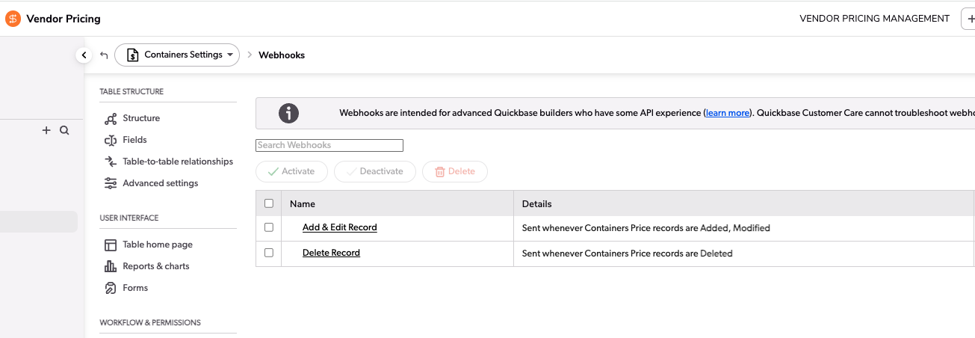

Hub app
The other way to sync all records is to click the 'Sync' button in Pricing > Settings in the Hub application. This option is only visible to users who belong to the “ZTERS.VendorManagement” group. This option syncs records for Toilets, Roll-offs, Containers, and Pricing Zones.
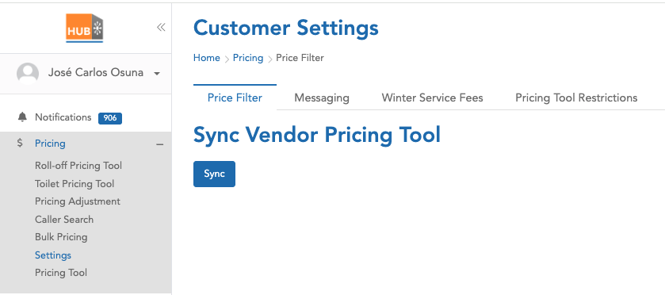

MySQL Database
The following are the fields saved in the MySQL database, along with their respective sources:
MySQL Field | Vendor Pricing QuickBase | FID
rid | Record ID# | 3
product_category | Product Type - Product Category | 11
product_type | Product Type | 13
pricing_zone_rid | Related Pricing Zone | 20
company_name | Company Name | 22
preferred_vendor | Preferred Vendor | 23
hauler_sales_rid | Hauler - Sales RID | 25
zone_type | Zone Type | 27
zip_list | Zip List | 33
zip_based | Pricing Zone - Zip List - Zip Based | 70
hauler_standard_charge | Standard Charge | 34
hauler_delivery_charge | Delivery Charge | 35
hauler_removal_charge | Removal Charge | 36
hauler_fuel_environ_percent | Fuel Environ % | 37
hauler_fuel_environ_dollars | Fuel Environ $ | 38
hauler_tax_percent | Tax % | 39
hauler_tax_dollars | Tax $ | 40
hauler_other_rate | Other Charge | 41
hauler_description | Other Description | 42
hauler_frequency | Other Billing Frequency | 43
hauler_dry_run_rate | Dry Run | 44
hauler_relocation_rate | Relocation | 45
address_miles | Pricing Zone - Address Miles | 59
depot_address | Pricing Zone - Depot Address | 60
depot_zip_code | Pricing Zone - Depot Address: Postal Code | 64
radius_miles | Pricing Zone - Radius Miles | 65
customer_standard_charge | Suggested Standard Charge 35% | 50
customer_delivery_charge | Suggested Delivery Charge 35% | 51
customer_removal_charge | Suggested Removal Charge 35% | 52
customer_total_charge | Suggested Total Charge | 58
pricing_zone_dnu | Pricing Zone - DNU | 76
dnu | DNU | 77
dnu_zone_or_individual | DNU - Zone or Individual | 78
added_rid | Internal | NA

Hub App > Pricing Tool
By applying filters such as Zip code and address, the Pricing tool in the Hub app shows records or suggestions based on the data stored in our database, originally imported from QuickBase. The following are the columns shown for Containers:
Column | MySQL Field
Provider Name | company_name
Category | product_category
Size | product_type
Rental / 28 days | customer_standard_charge
Delivery | customer_delivery_charge
Removal | customer_removal_charge

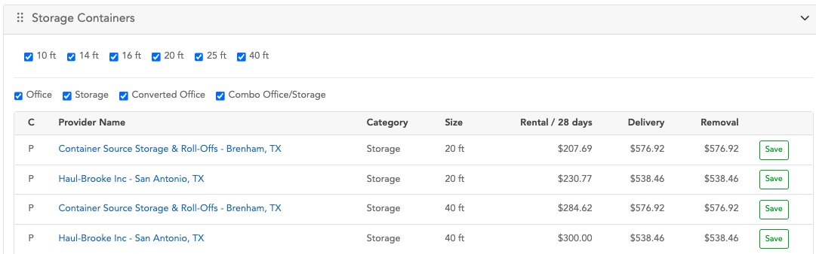
The value shown in the 'Rental / 28 days' column is, in some cases, different from the one saved in MySQL because a process applies certain pricing adjustments. These adjustments are designed to increase or decrease the final amount in that column and can be applied selectively to specific record IDs.

Pricing Adjustments Process
- Find a record in the pricingadjustment table, filtering by:
- Active
- Product: ‘all’ or ‘storage-container’
- is_applicable: ‘%Hub Pricing Tool%’
If there are no records in the previous table, no pricing adjustments are applied.

- The second step is to apply additional filters to the records retrieved from step 1:
- Check the expiration logic: if the 'is_expire' flag is set to '1' and the 'expire_date' is greater than or equal to the current date, or if the 'is_expire' flag is '0', the record continues processing.
- The second filter logic checks the value of the 'geography' column: records with the value 'all', or where the zip code is included in the list, are allowed to continue processing.

- The third step is to sort the records by priority and apply only the record with the highest priority.
Also, in a hierarchical manner, check whether it is necessary to apply the adjustment for specific PSPs:
- This applies if the record is of type 'some PSPs' or 'some confirmed prices', and the 'storage_container_id' column is not empty. If so, verify whether the suggestion record is included in the IDs stored in the 'storage_container_id' column.
- If the previous conditions are false, check whether the record type is 'all' or 'all PSPs', or if the product has a value of 'all'.

- The final record from the pricingadjustment table determines the amount to be increased or decreased. This adjustment can be applied to all records shown as suggestions, or to a specific record ID, depending on the value of the 'type' column (e.g., 'some PSPs' or 'some confirmed prices').
- If the ‘price_flag’ column has a value of “1”, the value in the ‘amounts’ column is directly considered as the amount to increase or decrease from the final total.
- If the ‘price_flag’ column has a value of “0”, the system takes the value from the ‘percentage’ column, divides it by 100, and multiplies the result by the original value from ‘customer_standard_charge’. This calculated value is then used to increase or decrease the final total.
- To determine whether the adjustment is an addition or a subtraction, the system uses the value in the ’price’ column, which indicates either increase or decrease.

Saving Records in QuickBase
When the user clicks the Save button, a “Container” is created in the Sales Management ZTERs app in QuickBase.
The new container record is created based on the following information:
Sales Management ZTER’s QuickBase | FID | MySQL Field | Rounded?
Site ID | 58 | Parameters from the request
Category | 341 | product_category
Status | 22 | “Quote in Progress”
Product Type | 344 | According the size (10ft, 20 ft, 40ft)
Standard Charge (Customer) | 14 | customer_standard_charge | Yes
Delivery Charge (Customer) | 12 | customer_delivery_charge | Yes
Removal Charge (Customer) | 13 | customer_removal_charge | Yes
Pricing Tool Quote | 748 | 1
Pricing Tool Delivery Charge | 749 | customer_standard_charge | Yes
Pricing Tool Rental Charge | 750 | customer_delivery_charge | Yes
Pricing Tool Qty | 751 | 1
Pricing Tool Diagnostics | 753 | Parameters from the request
Hauler ID | 57 | hauler_sales_rid
Pricing Tool - Vendor List | 754 | hauler_sales_rid
Pricing Tool - Zone RID | 755 | pricing_zone_rid
Delivery Charge (Hauler) | 7 | hauler_delivery_charge
Removal Charge (Hauler) | 8 | hauler_removal_charge
Standard Charge (Hauler) | 9 | hauler_standard_charge
Fuel Environ Percent (Hauler) | 10 | hauler_fuel_environ_percent
Fuel Environ Dollars (Hauler) | 11 | hauler_fuel_environ_dollars
% Tax (Hauler) | 112 | hauler_tax_percent
Tax $ (Hauler) | 166 | hauler_tax_dollars
Other Charge (Hauler) | 110 | hauler_other_rate
Other Description (Hauler Rate) | 373 | hauler_description
Other Billing Frequency (Hauler Rate) | 374 | hauler_frequency
Dry Run (Hauler) | 378 | hauler_dry_run_rate
Relocation (Hauler) | 380 | hauler_relocation_rate
As part of the new record, a note is added with specific information such as Hauler ID, Hauler Name, Category, Type, Standard Charge, Delivery Charge, and Removal Charge. For these charges, both the original value and the rounded price are included.

Example
Hub app: Pricing Tool
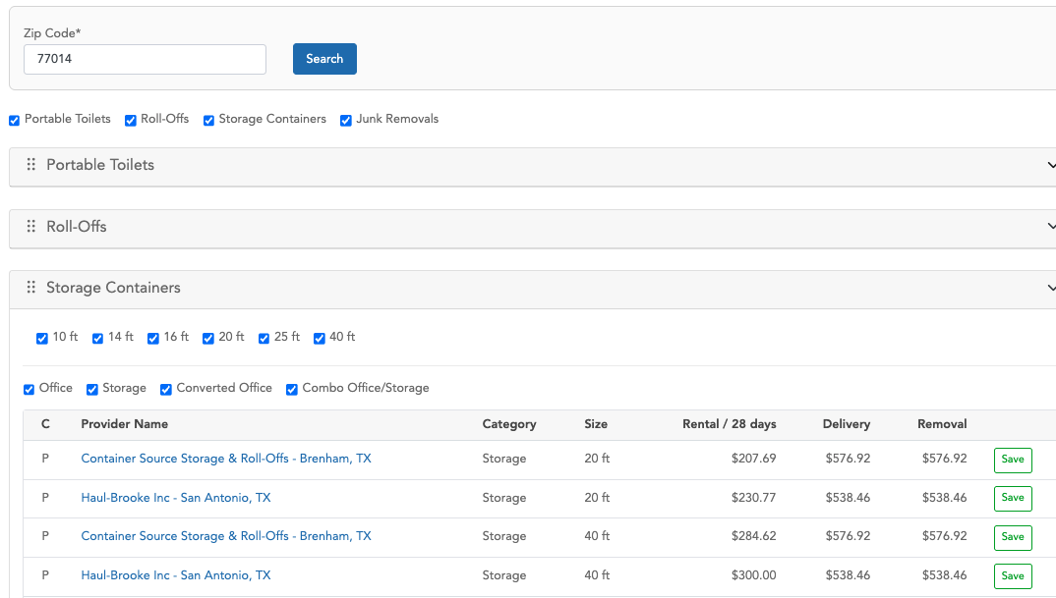
The following record was created using the first suggestion from the table, after clicking the Save button
https://zters.quickbase.com/nav/app/bhwfnx4uw/table/bhwgtqvvi/action/er?rid=53902
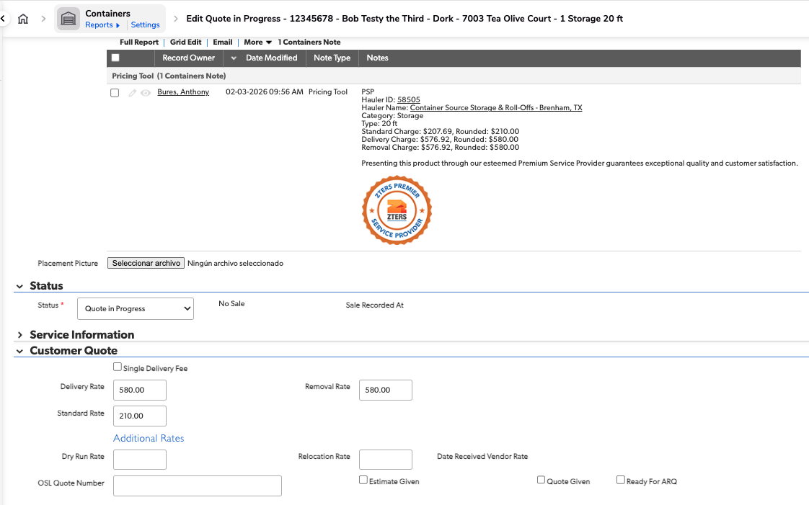
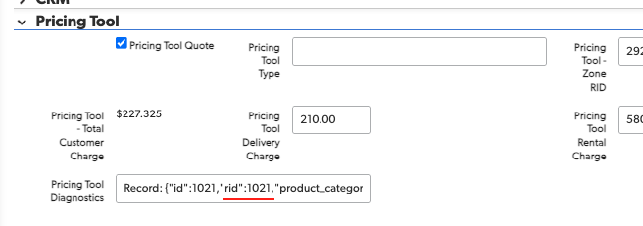
There is a Pricing Tool section in the Administrative tab. It displays the ID from the Vendor Pricing QuickBase, which, in this case, is record 1021.
https://zters.quickbase.com/nav/app/brd5gaz5n/table/breujuw2t/action/dr?rid=1021&rl=b8s
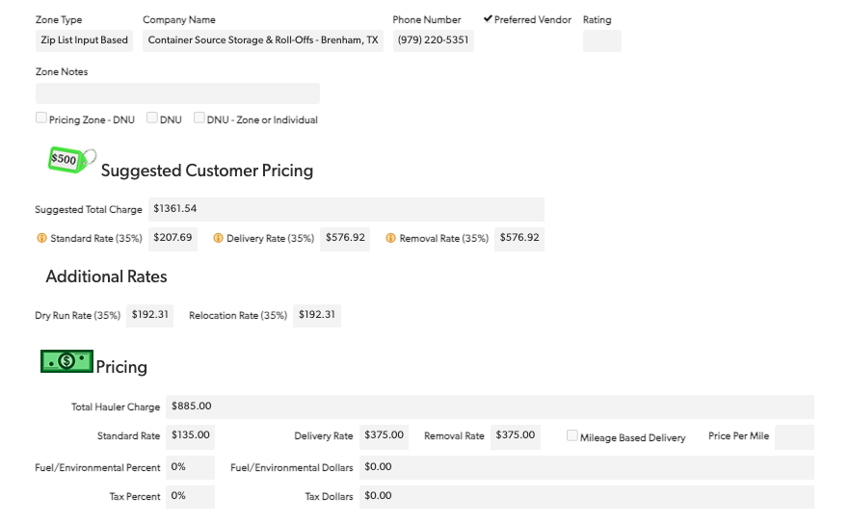
As you can see, the Standard Rate (35%), Delivery Rate (35%), and Removal Rate (35%) are the same as the values displayed in the Pricing Tool in the Hub app.

PORTABLE TOILET PRICING
The following information describes how PSP pricing works for toilets and explains the current pricing calculation.
1.
Vendor Pricing QuickBase
2.
Mysql Database
3.
Hub app: Pricing Tool
4.
Sales Management ZTER’s QuickBase

Vendor Pricing Records
Records from the Vendor Pricing app in QuickBase are saved into the MySQL database.

There are two ways to keep the records updated:

Vendor Pricing app in QuickBase
When a new toilet is added, or a record is edited or deleted, a webhook is triggered to update the corresponding record in the MySQL database.

Hub app
The other way to sync all records is to click the 'Sync' button in Pricing > Settings in the Hub application. This option is only visible to users who belong to the “ZTERS.VendorManagement” group. This option syncs records for Toilets, Roll-offs, Containers, and Pricing Zones.

MySQL Database
The following are the fields saved in the MySQL database, along with their respective sources:
MySQL Field | Vendor Pricing QuickBase | FID
rid | Record ID# | 3
3 | Record ID# | 3
11 | Product Type - Product Category | 11
13 | Product Type | 13
20 | Related Pricing Zone | 20
22 | Company Name | 22
23 | Preferred Vendor | 23
25 | Hauler - Sales RID | 25
27 | Zone Type | 27
33 | Zip List | 33
35 | Standard Charge | 35
36 | Delivery Charge | 36
57 | Pricing Zone - Address Miles | 57
58 | Pricing Zone - Depot Address | 58
62 | Pricing Zone - Depot Address: Postal Code | 62
63 | Pricing Zone - Radius Miles | 63
68 | Pricing Zone - Zip List - Zip Based | 68
71 | Standard Charge (Customer) | 71
72 | Delivery Charge (Customer) | 72
73 | Removal Charge (Customer) | 73
79 | Total Customer Charge | 79
93 | Service Frequency | 93
94 | Pricing Zone - DNU | 94
95 | DNU | 95
96 | DNU - Zone or Individual | 96

Hub App > Pricing Tool
By applying filters such as Zip code and address, the Pricing tool in the Hub app shows records or suggestions based on the data stored in our database, originally imported from QuickBase. The following are the columns shown for Portable Toilets:
Column | MySQL Field
Provider Name | 22
Product Name | 13
Frequency | Event: 11  Construction: 93
Standard | 71
Delivery | 72
Removal | 73

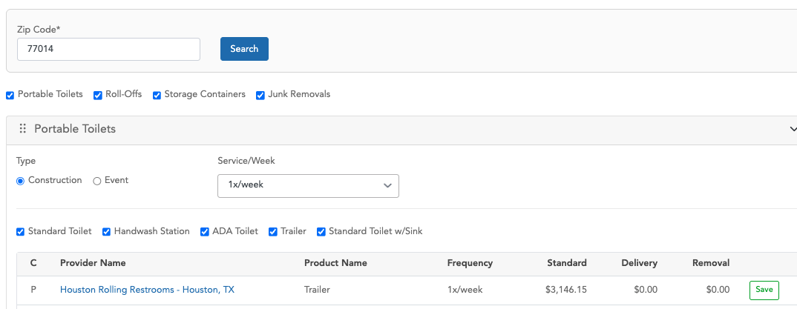
The value shown in the 'Standard' column is, in some cases, different from the one saved in MySQL because a process applies certain pricing adjustments. These adjustments are designed to increase or decrease the final amount in that column and can be applied selectively to specific record IDs.

Pricing Adjustments Process
- Find a record in the pricingadjustment table, filtering by:
- Active
- Product: ‘all’ or ‘toilet’
- is_applicable: ‘%Hub Pricing Tool%’
If there are no records in the previous table, no pricing adjustments are applied.

- The second step is to apply additional filters to the records retrieved from step 1:
- Check the expiration logic: if the 'is_expire' flag is set to '1' and the 'expire_date' is greater than or equal to the current date, or if the 'is_expire' flag is '0', the record continues processing.
- The second filter logic checks the value of the 'geography' column: records with the value 'all', or where the zip code is included in the list, are allowed to continue processing.

- The third step is to sort the records by priority and apply only the record with the highest priority.
Also, in a hierarchical manner, check whether it is necessary to apply the adjustment for specific PSPs:
- This applies if the record is of type 'some PSPs' or 'some confirmed prices', and the 'toilet_id' column is not empty. If so, verify whether the suggestion record is included in the IDs stored in the 'toilet_id' column.
- If the previous conditions are false, check whether the record type is 'all' or 'all PSPs', or if the product has a value of 'all'.

- The final record from the pricingadjustment table determines the amount to be increased or decreased. This adjustment can be applied to all records shown as suggestions, or to a specific record ID, depending on the value of the 'type' column (e.g., 'some PSPs' or 'some confirmed prices').
- If the ‘price_flag’ column has a value of “1”, the value in the ‘amounts’ column is directly considered as the amount to increase or decrease from the final total.
- If the ‘price_flag’ column has a value of “0”, the system takes the value from the ‘percentage’ column, divides it by 100, and multiplies the result by the original value from ‘customer_standard_charge’. This calculated value is then used to increase or decrease the final total.
- To determine whether the adjustment is an addition or a subtraction, the system uses the value in the ’price’ column, which indicates either increase or decrease.

Saving Records in QuickBase
When the user clicks the Save button, a “Toilet” is created in the Sales Management ZTERs app in QuickBase.

As part of preparing the information needed to create the record, the system performs a query directly to the Toilets entity in the Vendor Pricing app in QuickBase, rather than retrieving the data from our local database. It then uses the retrieved information to attempt to create the new record.
The new toilet record is created based on the following information:
Sales Management ZTER’s QuickBase | FID | Vendor Pricing QuickBase FID | Rounded?
Status | 9 | ‘Quote in Progress’
Standard Charge (Customer) | 19 | 71 | Yes
Site ID | 25 | Parameters from the request
Pricing Tool Rental Charge | 539 | 71 | Yes
Delivery Charge (Customer) | 17 | 72 | Yes
Pricing Tool Delivery Charge | 540 | 72 | Yes
Per Unit Delivery (Zters) | 458 | 34
Per Unit Delivery (Vendor) | 333 | 34
Category | 576 | 11
Frequency of Service | 54 | Event: Event  Construction: 93
Portable Toilet Sales | 824 | true
Standard Charge (Hauler) | 13 | 35
Delivery Charge (Hauler) | 11 | 36
Removal Charge (Hauler) | 12 | 37
Fuel Environ Percent (Hauler) | 15 | 38
Fuel Environ Dollars (Hauler) | 16 | 39
% Tax (Hauler) | 86 | 40
Tax Dollars (Hauler) | 202 | 41
Containment Tray Rate | 621 | 42
Hand Sanitizer Rate | 622 | 43
Locking Hasp Rate | 623 | 44
Pump Rate | 624 | 45
Rigging Cage Rate | 625 | 46
Other Charge (Hauler) | 91 | 47
Other Description (Hauler Rate) | 605 | 48
Other Billing Frequency (Hauler Rate) | 606 | 49
Winterization Fee (Hauler) | 488 | 50
Dry Run (Hauler) | 610 | 51
Extra Service Charge (Hauler) | 14 | 52
Service Rate After Hours/Weekends (Hauler) | 627 | 53
Relocation (Hauler) | 612 | 54
Vendor Pricing RID | 853 | 3
Hauler ID | 30 | 25
Removal Charge (Customer) | 18 | 73 | Yes
Product Type | 581 | 14
Pricing Tool Quote | 538 | 23
Pricing Tool - Zone RID | 902 | 20
Pricing Tool - Experiment (Test) | 1127 | 138
Pricing Tool - Experiment (Control) | 1128 | 139
Pricing Tool - Vendor List | 901 | 25 (If FID 23 ==1)
Cycle Time | 118 | Construction: 28 Days  Event: Event
As part of the new record, a note is added with specific information such as Hauler ID, Hauler Name, Product Name, Frequency, Standard Charge, Delivery Charge and Removal Charge. For the charge-related fields, both the original value and the rounded price are included.

Example
Hub app: Pricing Tool
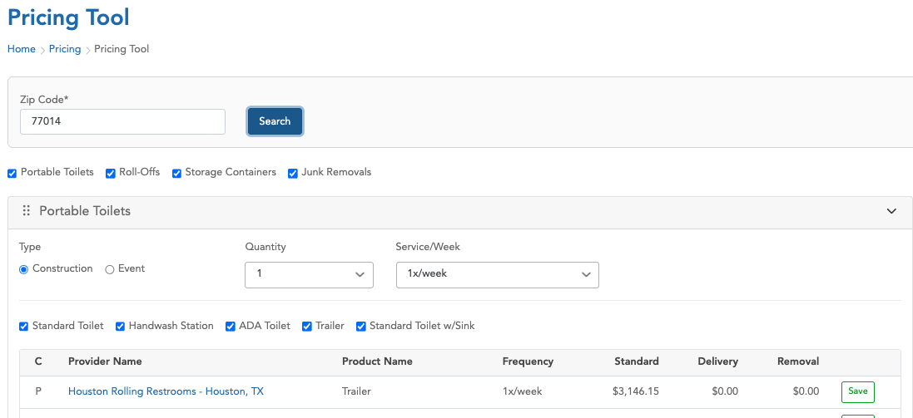
The following record was created using the first suggestion from the table, after clicking the Save button.
https://zters.quickbase.com/nav/app/bhwfnx4uw/table/bhwgum25y/action/dr?rid=1125608
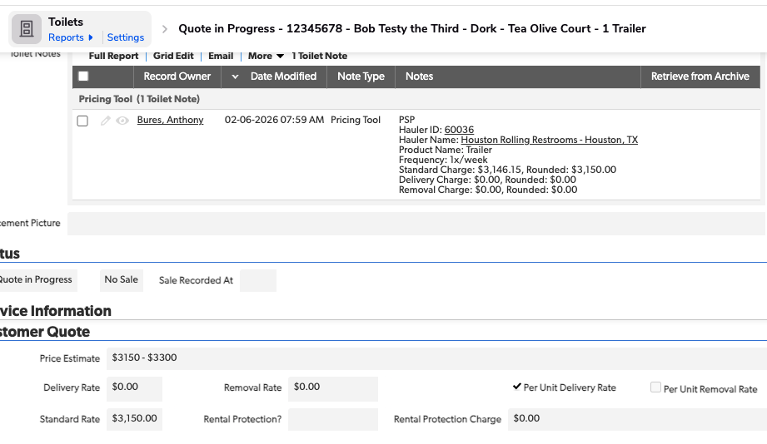
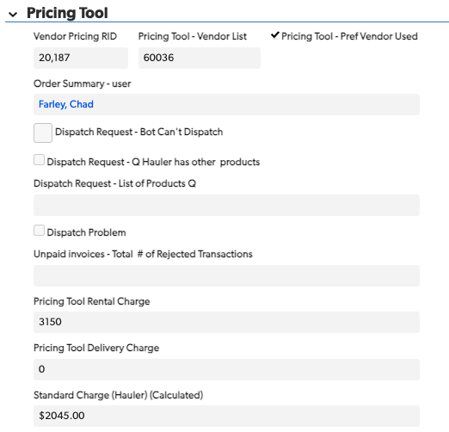

There is a Pricing Tool section in the Administrative tab. It displays the ID from the Vendor Pricing QuickBase, which, in this case, is record 20187.
https://zters.quickbase.com/nav/app/brd5gaz5n/table/breuj4sax/action/dr?rid=20187&rl=87
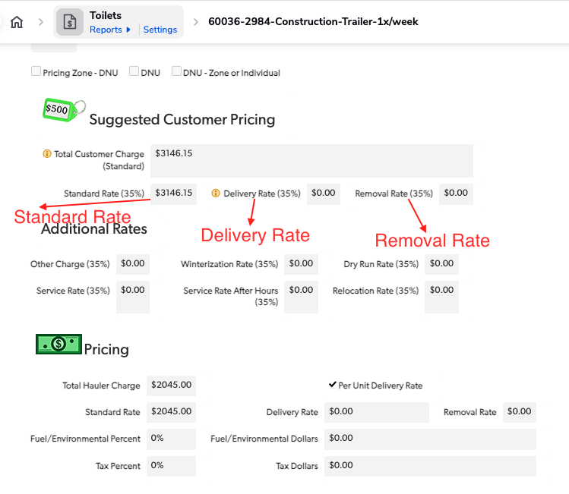
As you can see, the Standard Rate (35%), Delivery Rate (35%), and Removal Rate (35%) are the same as the values displayed in the Pricing Tool in the Hub app.

ROLL-OFFS PRICING
The following information describes how PSP pricing works for roll-offs and explains the current pricing calculation.
1.
Vendor Pricing QuickBase
2.
Mysql Database
3.
Hub app: Pricing Tool
4.
Sales Management ZTER’s QuickBase

Vendor Pricing Records
Records from the Vendor Pricing app in QuickBase are saved into the MySQL database.

There are two ways to keep the records updated:

Vendor Pricing app in QuickBase
When a new Roll-off is added, or a record is edited or deleted, a webhook is triggered to update the corresponding record in the MySQL database.

Hub app
The other way to sync all records is to click the 'Sync' button in Pricing > Settings in the Hub application. This option is only visible to users who belong to the “ZTERS.VendorManagement” group. This option syncs records for Toilets, Roll-offs, Containers, and Pricing Zones.

MySQL Database
The following are the fields saved in the MySQL database, along with their respective sources:
MySQL Field | Vendor Pricing QuickBase | FID
rid | Record ID# | 3
3 | Record ID# | 3
13 | Product Type | 13
21 | Related Pricing Zone | 21
23 | Company Name | 23
24 | Preferred Vendor | 24
26 | Hauler - Sales RID | 26
28 | Zone Type | 28
34 | Zip List | 34
36 | Standard Charge | 36
37 | Delivery Charge | 37
39 | Rental Charge | 39
43 | Ton Rate | 43
59 | Standard Charge +$140 (Suggested) | 59
117 | Standard Charge +$140 (Suggested) for 3-15 | 117
60 | Suggested Delivery Charge 35% | 60
61 | Days Allowed (Suggested) | 61
62 | Suggested Rental Charge 35% | 62
63 | Delivery Rate Per | 63
65 | Tons Included (Suggested) | 65
115 | Tons Included (Suggested) for 3-15 | 115
66 | Suggested Ton Rate 35% | 66
118 | Suggested Ton Rate 35% #2 | 118
69 | Debris | 69
70 | Pricing Zone - Address Miles | 70
71 | Pricing Zone - Depot Address | 71
75 | Pricing Zone - Depot Address: Postal Code | 75
76 | Pricing Zone - Radius Miles | 76
81 | Pricing Zone - Zip List - Zip Based | 81
87 | Pricing Zone - DNU | 87
88 | DNU | 88
89 | DNU - Zone or Individual | 89
91 | Total Customer Charge +$140 (Suggested) | 91

Hub App > Pricing Tool
By applying filters such as Zip code and address, the Pricing tool in the Hub app shows records or suggestions based on the data stored in our database, originally imported from QuickBase. The following are the columns shown for Roll-Offs:
Column | MySQL Field
Provider Name | 23
Size | 13
Debris | 69
Delivery | 60
Charge | 117
Days | 61
Rental Rate | 62
Tons | 115
Ton Rate | 118

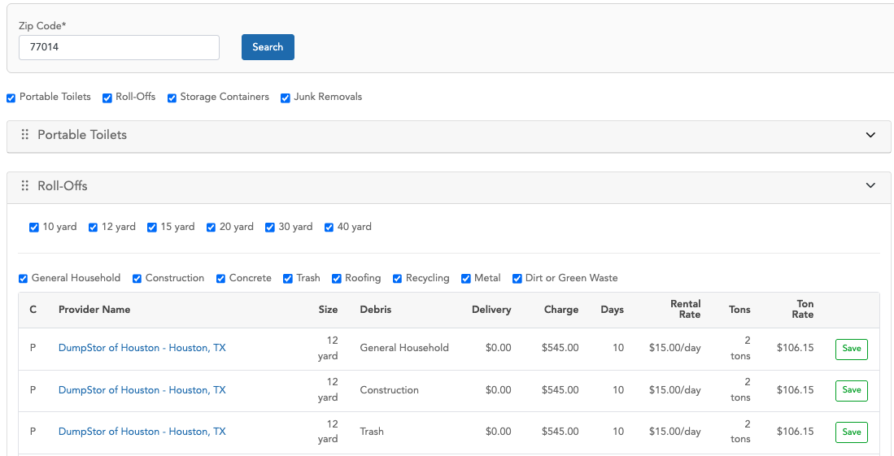
The value shown in the 'Charge' column is, in some cases, different from the one saved in MySQL because a process applies certain pricing adjustments. These adjustments are designed to increase or decrease the final amount in that column and can be applied selectively to specific record IDs.

Pricing Adjustments Process
- Find a record in the pricingadjustment table, filtering by:
- Active
- Product: ‘all’ or ‘dumpster’
- is_applicable: ‘%Hub Pricing Tool%’
If there are no records in the previous table, no pricing adjustments are applied.

- The second step is to apply additional filters to the records retrieved from step 1:
- Check the expiration logic: if the 'is_expire' flag is set to '1' and the 'expire_date' is greater than or equal to the current date, or if the 'is_expire' flag is '0', the record continues processing.
- The second filter logic checks the value of the 'geography' column: records with the value 'all', or where the zip code is included in the list, are allowed to continue processing.

- The third step is to sort the records by priority and apply only the record with the highest priority.
Also, in a hierarchical manner, check whether it is necessary to apply the adjustment for specific PSPs:
- This applies if the record is of type 'some PSPs' or 'some confirmed prices', and the 'dumpster_id' column is not empty. If so, verify whether the suggestion record is included in the IDs stored in the 'dumpster_id' column.
- If the previous conditions are false, check whether the record type is 'all' or 'all PSPs', or if the product has a value of 'all'.

- The final record from the pricingadjustment table determines the amount to be increased or decreased. This adjustment can be applied to all records shown as suggestions, or to a specific record ID, depending on the value of the 'type' column (e.g., 'some PSPs' or 'some confirmed prices').
- If the ‘price_flag’ column has a value of “1”, the value in the ‘amounts’ column is directly considered as the amount to increase or decrease from the final total.
- If the ‘price_flag’ column has a value of “0”, the system takes the value from the ‘percentage’ column, divides it by 100, and multiplies the result by the original value from ‘customer_standard_charge’. This calculated value is then used to increase or decrease the final total.
- To determine whether the adjustment is an addition or a subtraction, the system uses the value in the ’price’ column, which indicates either increase or decrease.

Saving Records in QuickBase
When the user clicks the Save button, a “Toilet” is created in the Sales Management ZTERs app in QuickBase.

As part of preparing the information needed to create the record, the system performs a query directly to the Rolloffs entity in the Vendor Pricing app in QuickBase, rather than retrieving the data from our local database. It then uses the retrieved information to attempt to create the new record.
The new roll-off record is created based on the following information:

Sales Management ZTER’s QuickBase | FID | Vendor Pricing QuickBase FID | Rounded?
Debris | 18 | 69
Size | 32 | 13
Quantity | 59 | 1
Status | 20 | “Quote in Progress’
Related Product Type | 441 | According to the size, the possible values for Product Type ID are:  10 yard => 73  12 yard => 74  15 yard => 75  18 yard => 76  20 yard => 77  25 yard => 78  30 yard => 79  35 yard => 80  default value 81
Product Type | 442 | It is the same case as in the row above
Site ID | 25 | Parameters from the request
PT Delivery Rate | 545 | 60 | Yes
Delivery Charge (Customer) | 14 | 60 | Yes
PT Rental Rate | 546 | 62 | Yes
Rental Charge (Customer) | 13 | 62 | Yes
PT Disposal Rate | 547 | 118 | Yes
Ton Rate (Customer) | 54 | 118 | Yes
Tons Included (Customer) | 33 | 115
Automatic Pull | 511 | 35
Standard Charge (Hauler) | 10 | 36
Delivery Charge (Hauler) | 9 | 37
Rental Charge (Hauler) | 8 | 39
Rental Type | 463 | 40
Rental Period Days | 464 | 55
Rental Rate Per Day | 776 | 56
Disposal Type (Hauler) | 453 | 41
Tons Included (Hauler) | 34 | 42
Ton Rate (Hauler) | 46 | 43
Standard Ton Rate Cutoff | 455 | 57
Conditional Ton Rate | 454 | 58
Fuel Environ Percent (Hauler) | 11 | 44
Fuel Environ Dollars (Hauler) | 12 | 45
% Tax (Hauler) | 97 | 46
Tax $ (Hauler) | 172 | 47
Other Charge (Hauler) | 95 | 48
Other Description (Hauler Rate) | 469 | 49
Other Billing Frequency (Hauler Rate) | 470 | 50
Dry Run (Hauler) | 472 | 51
Relocation (Hauler) | 474 | 52
Vendor Pricing RID | 742 | 3
Hauler ID | 35 | 26
Standard Charge (Customer) | 15 | 117 | Yes
PT Standard Rate | 544 | 117 | Yes
Days Allowed (Hauler) | 50 | 112
Pricing Tool | 542 | 24
Pricing Tool - Zone RID | 772 | 21
Pricing Tool - Experiment (Test) | 960 | 119
Pricing Tool - Experiment (Control) | 961 | 120
Pricing Tool - Vendor List | 771 | 26 (If FID 24 == 1)

As part of the new record, a note is added with specific information such as Hauler ID, Hauler Name, Size, Debris, Charge, Days Included, Rental Rate, Ton Rate, Tons, and Delivery Charge. For the charge-related fields, both the original value and the rounded price are included.

Example
Hub app: Pricing Tool
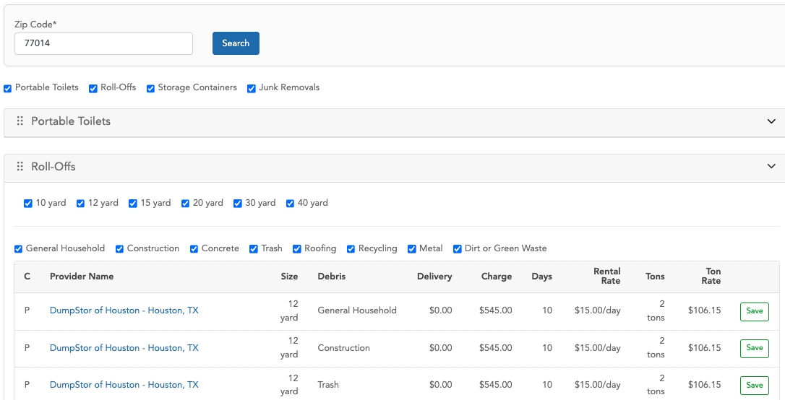
The following record was created using the first suggestion from the table, after clicking the Save button: https://zters.quickbase.com/nav/app/bhwfnx4uw/table/bhwgt8xdv/action/dr?rid=919241
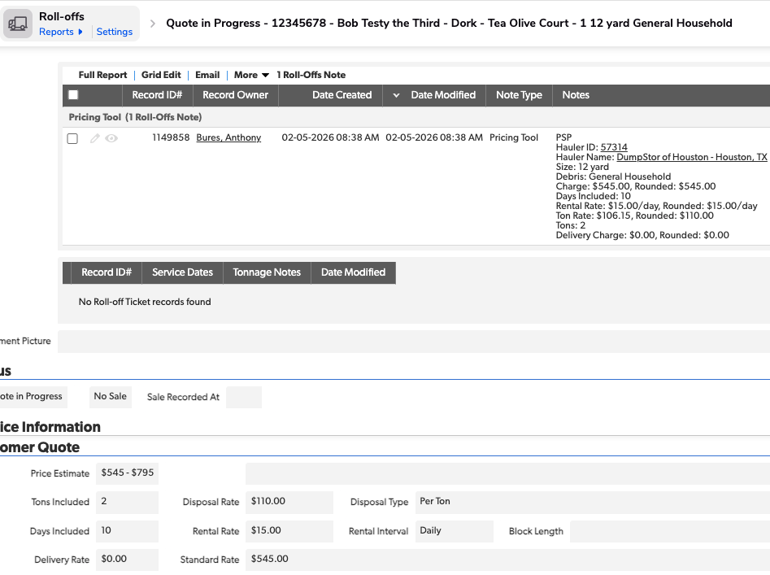
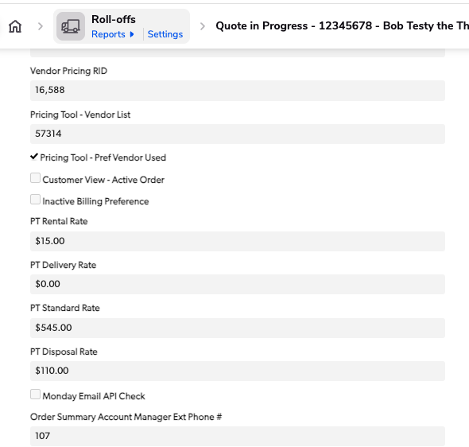
There is a Pricing Tool section in the Administrative tab. It displays the ID from the Vendor Pricing QuickBase, which, in this case, is record 16588.
https://zters.quickbase.com/nav/app/brd5gaz5n/table/breujw4za/action/dr?rid=16588&rl=vx3
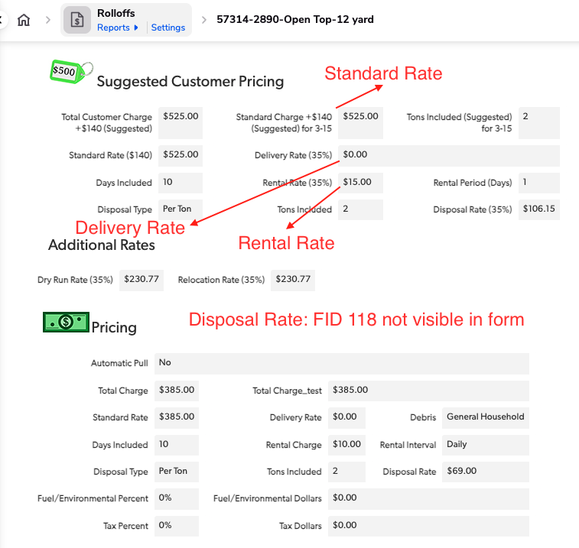
As you can see, the Standard Charge (+140, Suggested) for 3-15, the Delivery Rate (35%), Rental Rate (35%), and FID 118 (which is not visible in the form) are the same as the values displayed in the Pricing Tool in the Hub app—except for the Standard Charge. The values have a $20 increase due to the pricing adjustment process.

APPROVAL SIGNATURES
Digital signature blocks below are formatted for DocuSign / Adobe Sign.
Role | Name | Digital Signature Block | Date (dd/mm/aa)
Developer | Jose Carlos Osuna |  | 20/02/2026
Digital Development Manager | Anthony Bures |  | 20/02/2026

--- END OF THE DOCUMENT ---

